Girl Scouts of North-Central Alabama
Camp Coleman

Resident Camp Parent Information
Equestrian Escape

Camp Coleman 7717 Northlake Drive; Trussville, AL 35173

Arrive at Camp Coleman at 4:00 on Sunday Depart Camp Coleman at 4:00 on Friday
Thank you for registering for Resident Camp at Camp Coleman. We are looking forward to an exciting summer. Please review the following information and keep it in a convenient place to help you prepare for camp and ensure your camper has the best experience possible.
Equestrian Escape- Escape from the world as you learn to ride off into the sunset! Girls will spend 1 ½ hours at the barn each day where they will learn the basics of how to ride a horse. While not riding, girls will learn basic horse knowledge and care. Swimming, canoeing, archery, hiking, and crafts will ensure time spend away from the barn is packed with fun. Junior Girl Scouts will earn the Horseback Riding Badge. This program is ideal for girls with little or no horseback riding experience (have ridden independently 10 or fewer times.

About the Resident Camp Program
Girls participating in horseback riding camps will spend 1 ½ hours at the barn each day. This time will be spent riding (weather permitting), learning general horse knowledge, caring for horses, and more.
While not at the barn, campers will participate in additional camp activities that may include: boating, hiking, archery, sling shots, riflery, crafts, tea parties, rock wall climbing, games, hole digging, rock throwing, creek stomp, STEM activities, tubing, dam building, fire building, s’more making, and more.
Before summer camp:
- Talk to your camper about summer camp. Let them know what to expect. https://www.acacamps.org/resource-library/parents/preparing-children-summer-camp-experience
- Make sure all forms are completed and all questions are answered honestly. The questions are a tool for the summer camp staff to be best prepared for your camper. The information is confidential and is only shared with staff members who really need to know.

Where will campers sleep?
Campers will sleep either in cabins or bunk houses. Most campers sleep in small cabins with 2-3 campers in each cabin. Cabins have screen walls, so the experience is similar to sleeping on a screened in deck. A bath house is a located nearby. A dusk to dawn light in the middle of each group of cabins helps campers navigate the area at night. Counselors sleep in a separate cabin, within hearing distance of the campers.

Cabin Mates
Girls can request to be in the same cabin with another girl who is coming to camp at the same time and is close to the same age by completing the cabin mate portion of the registration form. Because of reduced capacity, many cabins will only have 2 girls in them. Please list only your top choice for cabin mate.

Packing for camp
Packing for camp doesn’t have to be a challenge. Start early. When purchasing summer clothes, keep camp in mind. Things at camp will get dirty, they may get damaged, and unfortunately occasionally lost. Please keep this in mind and do not send anything to camp that you would be devastated if it returned ruined or did not return at all. In an effort to reduce lost items, we have partnered with Mable’s Labels. This company creates high quality labels that are made for camp life. Girl Scouts of North-Central Alabama also receives a percentage of the proceeds of your purchase. If you choose not to purchase sew on labels, please write your camper’s name (not initials) on EVERYTHING!
Packing List
Clothing (Packed in trunk or suitcase):
- 7 T-shirts
- 7 pairs of shorts
- 10 pair of underwear and bras for the week
- 10 pair of socks
- 3 pair of tall socks for boots
- Tennis shoes
- Water shoes (Chaco/ Keen type- NO FLIP FLOPS)
- 2-3 modest bathing suits
- 3-5 pair of long pants that come to ankle (jeans/ leggings are acceptable)
- Rain jacket/ poncho
- Long sleeved shirt/ sweatshirt/ long pants
- Boots with smooth sole and heel (See pictures and info below)
Shower/Bathroom (Packed in Shower Tote):
- Bath towel/ wash cloth/ body poof
- Swim/ beach towel
- Shower tote
- toiletries (shampoo, conditioner, body soap toothbrush, toothpaste, deodorant, hairbrush, etc.)
- Flip Flops to wear in the shower
- Feminine Hygiene products (Please provide the camper with instructions on proper disposal.)
Bedding
- Twin sized sheets and blanket or sleeping bag (Mattress protector optional)
- Pillow/ camp friendly stuffed animal

General Camp Supplies
- Refillable water bottle that fully closes
- Small backpack
- Lifejacket (optional but strongly recommended)
- Hat/ sunglasses (optional)
- Stationary/ pens/ stamps (preaddressed envelopes are helpful)
- Dirty laundry bag
- Cards, book, puzzle games, etc.
- Equestrian helmet with manufacture date of 2014 or newer. (See link below.)
- Flashlight (with new batteries)
- Sunscreen
- Insect repellant
Do not bring: pets, alcohol, tobacco, e-cigarettes, firearms, fireworks, explosives. Any Camper found to be in possession of these items will be sent home from camp. No refund will be given.

Pack separately: medications (prescription, over the counter, topical, vitamins/ supplements)

There is no need to lock trunks or bags at camp. GSNCA cannot be held responsible for lost keys or locks that must be destroyed because the key has been lost.

Horseback Riding Supplies
A schooling helmet will be an affordable option. Sizing instructions are available online. Either paddock boots or cowboy boots are appropriate. (hiking boots, Uggs, duck boots or other shoes with thick soles or no heel are not safe for horseback riding) Boot socks are important. No show/ ankle socks often leave areas that are likely to get rubbed by boots. Crew length or boot socks are a much better option.
Jeans, leggings, or riding tights/ breeches/ jodhpurs are all acceptable. Pants should be normal full length- no capris. Campers will wear pants and boots about 2 hours each day. Please pack at least 2 pair of pants.
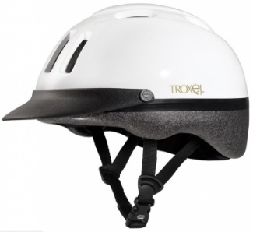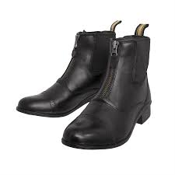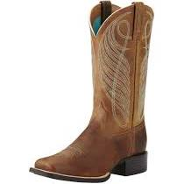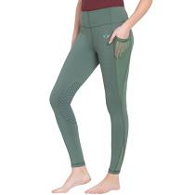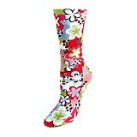

Dover Saddlery; Stateline Tack; Jeffers Equine are all reputable stores to shop. Locally, Tractor Supply sells helmets and boots on a limited basis. Huntsville Horse Sports and Carousel Tack Shoppe (south of Birmingham) are full tack shops with knowledgeable staff to help you with your purchases. Atlanta and Nashville have many tack shops to choose from if you happen to be in those areas.

Packing Tips
Your camper’s belongings will be stored on the floor, in the container that you pack in. Foot lockers seem to help keep everything in one place and allow your camper easy access while they are at camp. Campers can benefit by having outfits packed in zip lock bags for each day and extra clothes in additional bags. A list of what you actually pack is helpful in making sure that everything leaves camp with your camper. Make the list descriptive enough so the camper knows not only that they are missing a pair of shorts, but that they are missing a pair of red and black running shorts.
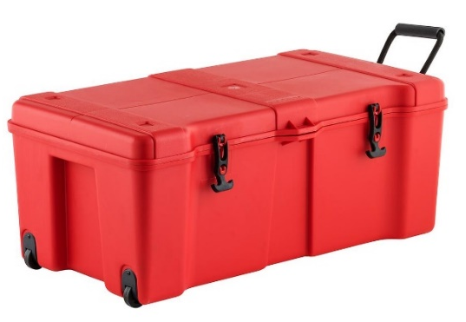
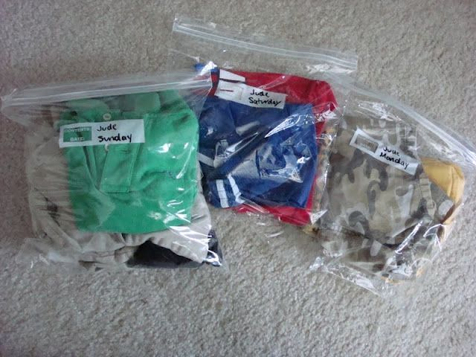

Cancelations/ Refunds
Registrations may be canceled at any time. The $50 deposit is non-refundable. The amount of the balance of the fees paid will be refunded based on when cancelation request is made. Requests made prior to 4 weeks before start of camp session will be refunded 100 % (Less $50 deposit). Cancelations made 2-4 weeks prior to the start of camp session will be refunded 50% (Less $50 deposit). Registrations made less than 2 weeks prior to the start of the camp session, are not guaranteed a refund. Refund requests for registrations cancelled less than 2 weeks prior to the start of the camp session or in the event of true emergency/ medical need will be determined by GSNCA CEO. All requests must made via email. Requests to cancel should be emailed to Amie Martin amartin@girlscoutsnca.org

Camp Store
Campers will also have the opportunity to purchase camp souvenirs like T shirts, patches, and trinkets. Prices range from $1- $25. The Camp Store will be open during the week for girls to make purchases. Parents can also pre order items. Items that are preordered will be in the camper’s cabin when they arrive at camp.

Food at Camp
Food at camp is very important. The average camper walks 20, 000 steps or more each day and is expending a great deal of energy doing camp activities. Meals are prepared in a commercial kitchen that is inspected by the local health department. The menu consists of popular food items that most campers enjoy. Breakfast and lunch will be served in the cabin unit eating areas. Campers will pre- order food and options (similar to room service). Meals will be individually packaged. Counselors will receive training for safely distributing food/ drinks and managing mealtimes. Dinner will be served in shifts in the dining hall. Portion sizes are not controlled, and there is always enough food for a second serving. Snack is served each afternoon and will be delivered to the cabin unit.
If your camper has special food dietary needs, please contact jdick@girlscoutsnca.org to discuss how we can best meet these requests. Requests not received at least 2 weeks in advance, cannot be guaranteed.

Daily Schedule
A typical day may look like this:
- 7:30 wake up
- 8:00 breakfast in cabin unit
- 9:00 horseback riding
- 10:30 archery
- 12:00 lunch in cabin unit
- 1:00 canoeing
- 2:30 STEM activity
- 4:00 Swimming
- 6:00 supper in dining hall
- 8:00 evening activity/ showers
Camp Staff
Camp is led by an administrative team with a combined 50 years of camp leadership experience. Summer camp staff consist of young adults. All staff must undergo an application and interview process complete with reference checks, background check and drug screening. All summer camp staff will be trained in first aid and CPR as well as specific camp activities that they will be assigned to lead. Staff also participate in an intensive training period that includes sessions on child development, being a good mentor, recognizing and preventing bullying, conflict resolution, positive discipline, camp procedures, emergency procedures, leading activities, diversity and inclusion, and many other topics designed to ensure your camper has a positive, safe camp experience. An adult health care manager; the maintenance team; and the kitchen staff all work together to make sure operations run smoothly and help keep everyone safe.

Health Care at Camp
All summer camp staff will be trained in first aid and CPR. A designated first aider is onsite at all times. Local Emergency Medical Services will be notified of the summer camp schedule and are familiar with the camp’s location and layout. Medical professionals are also on call, just a phone call away.
The first aid area is well stocked with common over-the-counter medications and health care essentials.

Medication
Campers’ medications will be stored in a locked cabinet in the camp office except for emergency inhalers and epi pens. All medications must be in the original container. Medications will be dispensed as directed unless accompanied by instructions from the prescriber. Emergency inhalers and epi pens will be with the camper in the care of their counselor. Please label the actual inhaler/ epi pen in the event that it is accidentally separated from the original box.
Please complete the medication form and include it with your camper’s medication. Please note that the mobile health care center at camp is well stocked with common over the counter medication. There is no need to send Tylenol, bug bite medication etc. with your camper. If they need it, we have it on hand.

Technology at Camp
We understand that in today’s world, everyone is connected through technology. Girls may bring their device with them, but will only be allowed to use it for about an hour a day, during shower time. The rest of the time, technology devices will be stored in a secure location. Wi-Fi is NOT AVAILABLE at Camp Coleman. Staff will not monitor usage or determine what content is accessed by campers. For the safety of all campers, location services must be turned off. All devices, chargers and accessories should be well labeled. Girl Scouts of North-Central Alabama will not be responsible to damage to, loss, or theft of any electronic devices.
Pictures at Camp
Staff will take pictures and videos of campers to be posted on the photo sharing page. Access to the photo sharing page will be provided to caregivers. Due to technology limitations, photos will not be posted until after campers leave. Campers may bring their own camera if desired.
Mail
Campers love to receive mail. Be sure to write to your camper and encourage friends and relatives to do the same. Please keep letters cheerful and positive. We suggest sending mail a week in advance of the camp session, so that your camper will mail the first day. You can also drop mail at check-in. Please do not include food, drinks, or candy in mail packages.
Campers enjoy writing home so be sure to send stationery and stamps. Prepare and send self-addressed envelopes or cards to make mailing easier.
Please mail letters to: Camper’s Name
Camp Coleman
4010 Camp Coleman Road
Trussville, AL 35173
Camp Rules
- Absolutely no tobacco/ e-cigarettes, alcoholic beverages, illegal drugs, fireworks, explosives, or pets are allowed at camp.
- Use the buddy system and use a flashlight at night. Do not leave the group/ area without notifying a counselor.
- Let counselors know if you need help.
- Wear the appropriate shoes and clothes to each activity. Campers who arrive at an activity not wearing the appropriate shoes or clothes will not be allowed to participate.
- Bullying, hazing, physical/ emotional torment, initiation practices, forced rituals and the like are strictly prohibited.
- Help keep camp clean! Pick up trash when you see it.
- Do not bring food, candy, or drinks into the cabins. The smell of these items attracts insects, animals, and worse. Chewing/ bubble gum is strictly prohibited at camp.
- Parents will be contacted to pick up any camper who exhibits behavior that is dangerous, disruptive, destructive, endangers other participants, or disrupts the program to such an extent that it negatively impacts the experience for other campers. If a camper is dismissed for these reasons, there will be no refund or reduction in camp fee.
- Parents will be required to reimburse Girl Scouts of North-Central Alabama for any damages caused by a participant to property including graffiti, torn, or cut screen, damaged beds, buildings, program equipment, etc.

When will we call you?
The summer camp staff will notify caregivers in the event of:
- Medical emergencies- in true emergencies, EMS will be called then the parent notified. Unless specifically requested otherwise, the child will be transported to the hospital via ambulance accompanied by a summer camp staff member.
- Non-emergent, serious, medical situations (potential broken bone/ cut requiring sutures) The camp staff will notify the caregiver who will have the option to pick the camper up from camp, meet camp staff at a medical facility, or request transportation via ambulance.
- Illness/ significant injury- The camp staff will notify you in the event of your camper being seen by the first aider for an injury requiring more than a band aid, or illness with fever or vomiting. Any camper exhibiting symptoms of COVID-19 will be isolated and must be picked up from camp within 2 hours of first symptom. Camper will not be allowed to return to camp until a negative COVID test result is available.
- If the child is reported to exhibit abnormal behavior believed to be caused by a medical/ mental health condition.
- If the child violates a camp rule repeatedly or breaks multiple camp rules.
- If the child’s behavior is dangerous to themselves or disruptive to the general camp population.
- If the child is homesick to the point that the camp staff feel that parental consultation will be beneficial.

Leaving Camp early/ for appointment
If your daughter needs to leave camp for any reason, please let the camp director know as soon as possible. Come to the camp office to sign your daughter out and pick up all belongings that she will be taking with her. Due to COVID restrictions, any camper who leaves camp, will not be able to return.

Authorized Pick Up
Campers will only be allowed to leave camp property with the persons listed as “Authorized Pick- Up.” Parents should be listed as authorized pick-ups. If the authorized pick-up list needs to be changed while your camper is at camp, please notify the camp director via email. jdick@girlscoutsnca.org

Arrival at Camp: NEW for 2021
- Camp Coleman is located at 7717 Northlake Drive, Trussville, AL 35173.
- Check in
  - Will begin at 4:00PM Sunday evening.
    - You will receive a check in appointment time to assist in the new check in format. Appointments will be scheduled between 4:00 and 4:45 pm
  - Check in will be a drive through process.
  - Only campers will be allowed to exit the vehicle.
- Stop at welcome station near the entrance to camp.
  - Pay any balance due
  - Receive instructions for the rest of check in
- Drive to check in tent
  - Daughter will have health screen while sitting in the car (door will need to be opened)
  - Drop off medication
- Proceed to assigned cabin unit
  - Camp counselors will assist with getting camper’s belongings out of vehicle.
  - Camp counselors will help camper get belongings to cabin, make bed and get settled in
  - Only campers will be allowed to exit the vehicle.
- Proceed to mail drop area on the way out of camp. Leave mail if desired.
Pick Up from Camp
- Camp ends at 4:00 on Friday. Campers will be busy with activities up until that point.
- When you arrive at camp, drive to the check-out area to sign your camper out. Please have a photo ID available to verify that you are an authorized pick-up person.
- Pick up any medication from the first aider.
- Drive to your camper’s cabin to meet your camper and collect her belongings.
- Remember to drive carefully out of camp as campers use the road as a sidewalk.

